riteSCAN
PO Receipt From Inspection Module
The riteSCAN PO Receipt From Inspection module replicates the “Purchase Order Inspection” program in SYSPRO.
The SYSPRO help file is also useful in learning more about the process and the various fields available. Open the SYSPRO Help File, then click Program List, Purchase Orders, Purchase Order Processing, Purchase Order Inspection, then click the link for Inspection Details (see screenshot at the end of this document).
The basic use of this module in riteSCAN is outlined below with screenshots for each available tab (Count, Inspect, Scrap, Reject, Return, and Accept)

Count
You use the Count option to indicate the quantity of the item counted.
- Enter the GRN number for the Purchase Order.
- Enter the quantity of the item counted.
- Select this to indicate that the count is complete (i.e. you will not be counting any further quantities for the item).
- Click Post
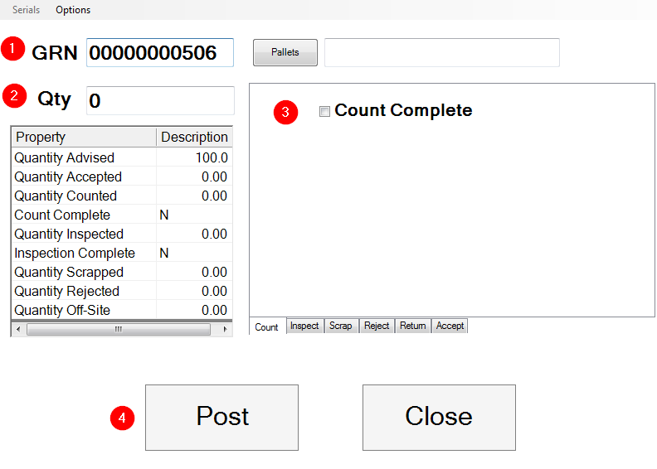

Inspect
You use the Inspect option to indicate the quantity of the item inspected.
- Enter the quantity of the item inspected.
- This indicates the reference number for the inspection document.
- Select this to indicate that the inspection is complete (i.e. you will not be inspecting any further quantities for the item).
- Click Post

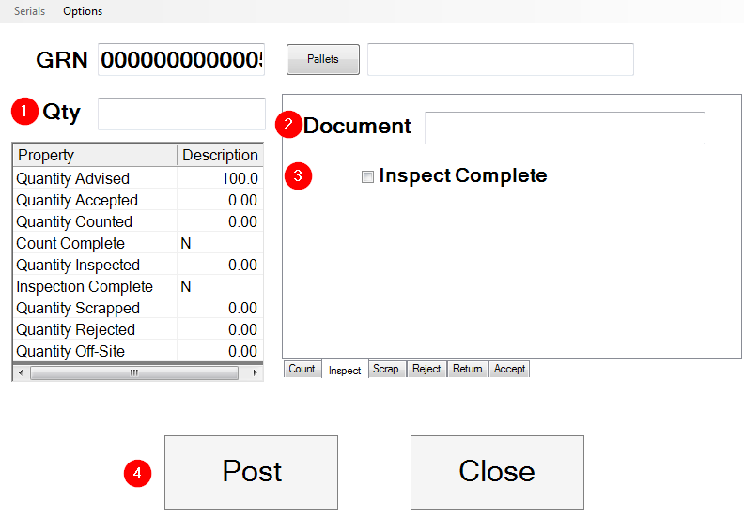

Scrap
You use the Scrap option to enter the quantity of the item which has been scrapped, together with a reason for the scrapping.
You would typically scrap an item that is beyond economical repair or an item that is being used for testing.
- Enter the quantity of the item scrapped.
- This indicates the reference number for the scrap document.
- Indicate the reason for scrapping the item(s).
- Enter a narration, if required. This text can be printed on inspection documents.
- Click Post
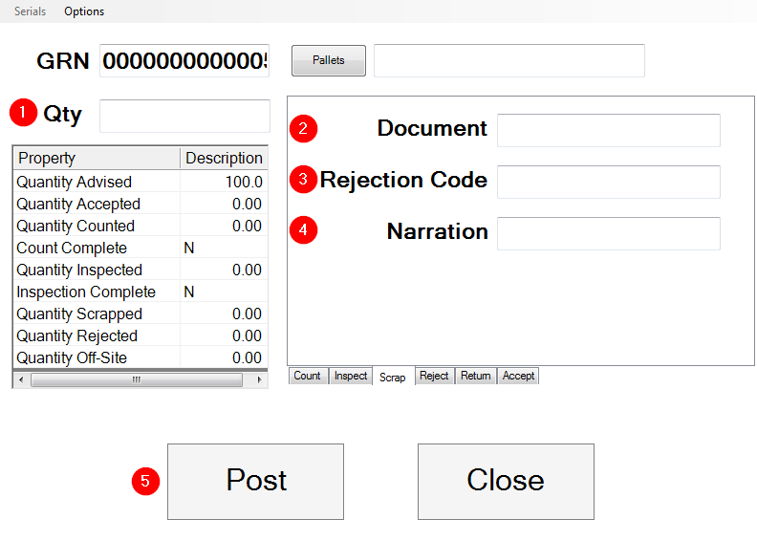

Reject
You use the Reject option to indicate the quantity of the item rejected.
A rejected item is typically one that could be still repaired. It could be returned to the supplier for repair or sent to an internal department for repair. Another reason for rejecting items could be that the supplier delivered the items too early or too late.
- Enter the quantity of the item rejected.
- This indicates the reference number on the reject document.
- Indicate the reason for rejecting the item(s).
- Enter a narration, if required. This text can be printed on inspection documents.
- Select this if the rejected items are being returned to the supplier.
- Indicate the supplier to whom the rejected items are being returned.
- Click Post
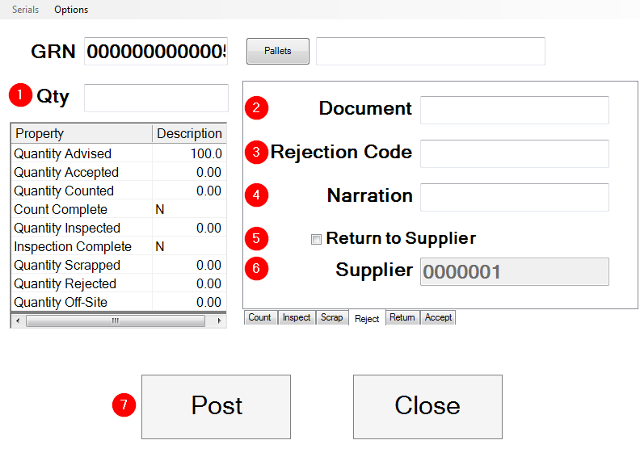

Return
You use the Return option to enter the quantity of the item which has been returned from the supplier and needs to be inspected and accepted into stock.
Typically, these items would have been rejected and are now being returned to you for re-inspection and acceptance.
- Enter the quantity of the item returned to you from the supplier.
- Enter the reference number for the return document. This would typically be the Reject document number you created when you initially rejected the item(s)
- Enter a narration, if required. This text can be printed on inspection documents.
- Select this if the item was returned to you from the supplier.
- Select this to receipt the returned quantity into a new lot number.
- Click Post

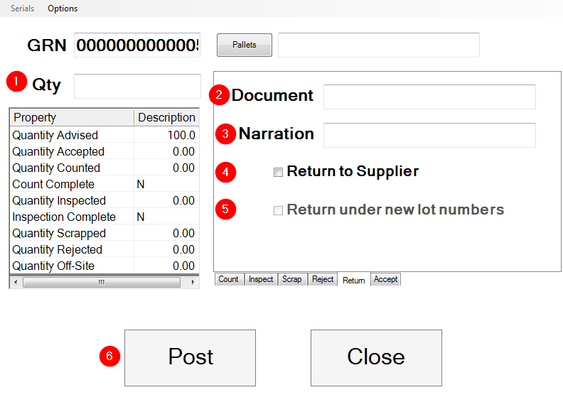

Accept

You use the Accept option to receipt the goods which have been inspected into stock.
- Enter the quantity to be received from inspection into stock.
- Enter a concession reference associated with the specific Lot, if applicable.
- These options indicate the cost basis for the line item. The cost basis specified at the time of entering the purchase order is used as the default, but can be changed.
- This only applies when Multiple bins in use is enabled against the warehouse into which you are receipting the item.
- Enter a notation that can be printed on the journal report.
- Click Post

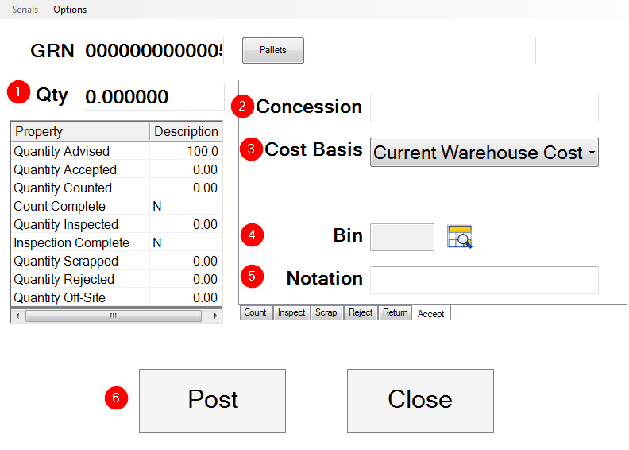

See below for the path to the SYSPRO help file’s article on Purchase Order Inspection (shown is SYSPRO 7).
